***GIT Assignment Questions***

### **1. Setting Up Git:**

* **Q1:** Install Git on your system and configure your name and email using the following commands:
  + git config --global user.name "Your Name"
  + git config --global user.email "[your.email@example.com](mailto:your.email@example.com)"
* **Ans:** 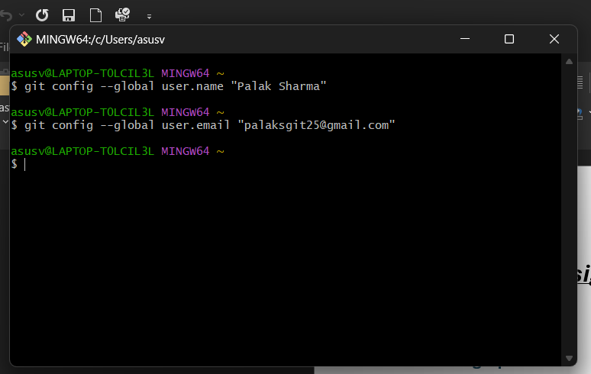
* **Q2:** How would you verify that Git has been installed and properly configured? Provide the command and the expected output.
* **Ans:** 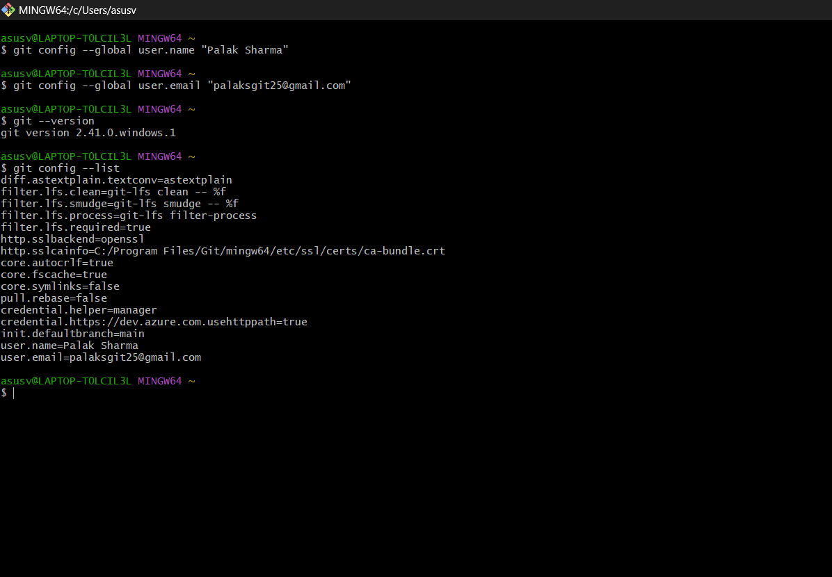
* **Q3:** Initialize a new Git repository in an empty directory on your computer using git init.
* **Ans:** 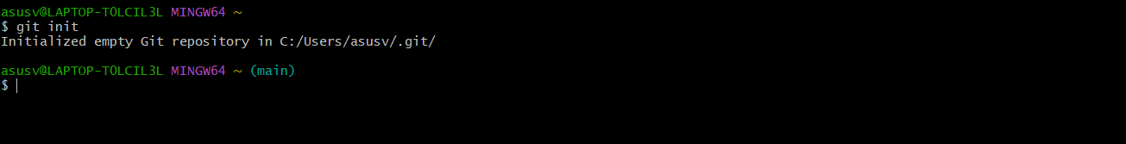

### **2. Basic Git Operations:**

* **Q4:** Create a new text file named hello.txt in your repository. Add some content to it. Then, stage the file for commit using the git add command.
* **Ans:** 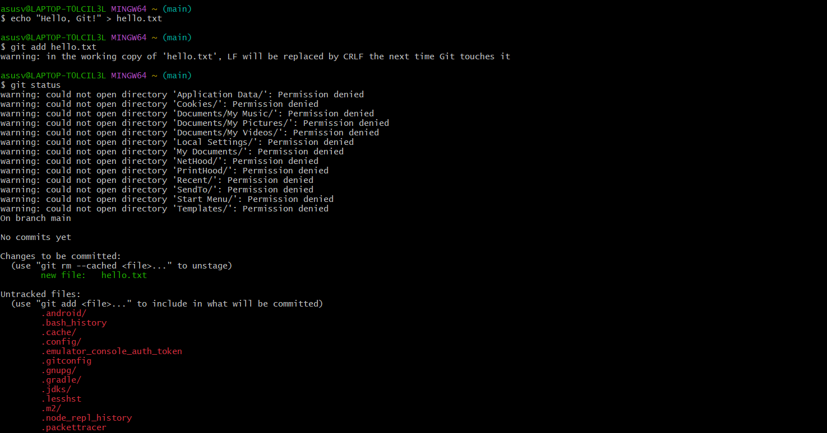
* **Q5:** Commit the changes you made to the hello.txt file with a meaningful commit message. Provide the Git command to commit and the expected output.
* **Ans:** 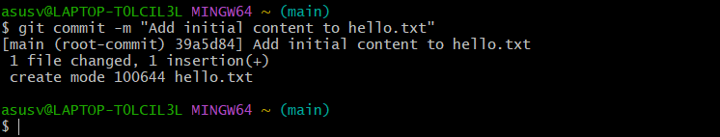
* **Q6:** After committing your changes, use the git status command to check the state of your repository. Explain the output.
* **Ans:** 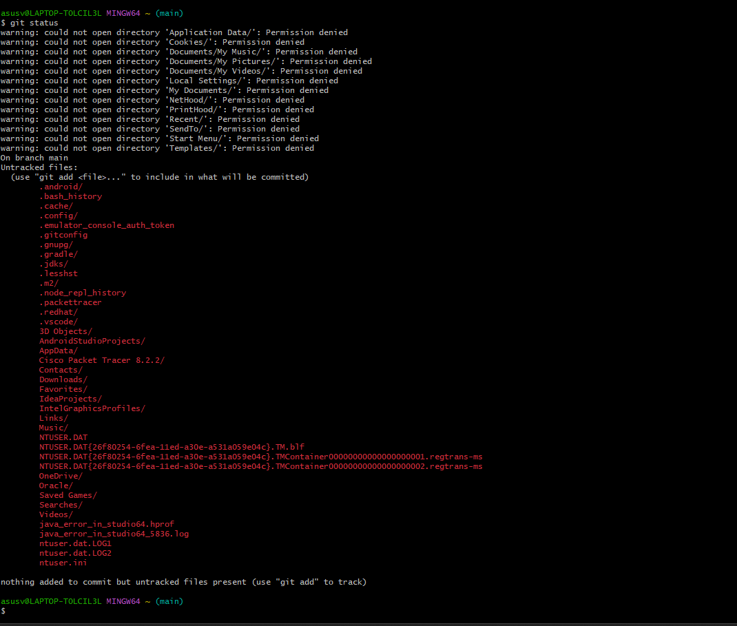
* **Q7:** How can you view the commit history of a repository? Use the git log command and describe what information it provides.
* **Ans:** 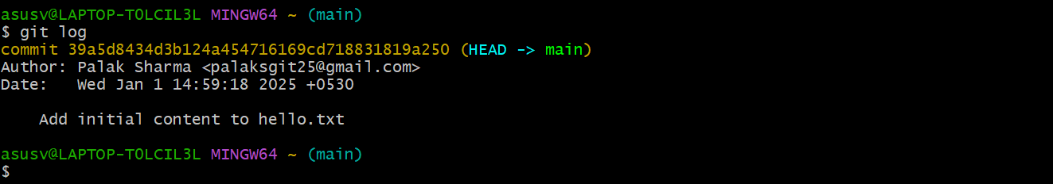

### Information Displayed:

1. **Commit Hash**: A unique SHA-1 identifier for each commit.
   * Example: commit 39a5d8434d3b124a454716169cd718831819a250 (HEAD -> main)
2. **Author**: The name and email of the person who made the commit.
   * Example: Author: Palak Sharma <palaksgit25@gmail.com>
3. **Date**: The timestamp of when the commit was created.
   * Example: Date: Wed Jan 1 14:59:18 2025 +0530
4. **Commit Message**: A descriptive message provided by the author to explain the changes made.
   * Example: Add initial content to hello.txt

### **3. Branching and Merging:**

* **Q8:** What is the purpose of branching in Git? How do branches help in software development?
* **Ans:** The purpose of branching in Git is to create separate lines of development within a repository. Branches allow developers to isolate their work, enabling parallel development and better collaboration. They are a fundamental feature of Git and play a vital role in modern software development workflows.
* **Benefits of Branching in Software Development:**
* **Isolation of Work**:
* Each branch represents an independent working environment.
* Developers can work on features, bug fixes, or experiments without affecting the main codebase.
* **Parallel Development**:
* Multiple developers can work on different branches simultaneously.
* Teams can work on new features while others fix bugs or maintain older versions.
* **Safe Experimentation**:
* Branches allow experimentation with new ideas without risking the stability of the main branch.
* If an experiment fails, the branch can be deleted without impacting the rest of the project.
* **Improved Collaboration**:
* Branching makes it easier for team members to review and integrate changes.
* Changes can be discussed and refined in isolation before merging them into the main branch.
* **Version Control and Tracking**:
* Branches can represent specific versions of the software (e.g., release-v1.0 or hotfix-issue123).
* This approach simplifies maintaining older versions alongside active development.
* **Continuous Integration and Deployment (CI/CD)**:
* Branches facilitate workflows like feature branches, pull requests, and code reviews, which integrate seamlessly with CI/CD pipelines.
* **Q9:** Create a new branch called feature-branch and switch to it using the appropriate Git command.
* **Ans:** 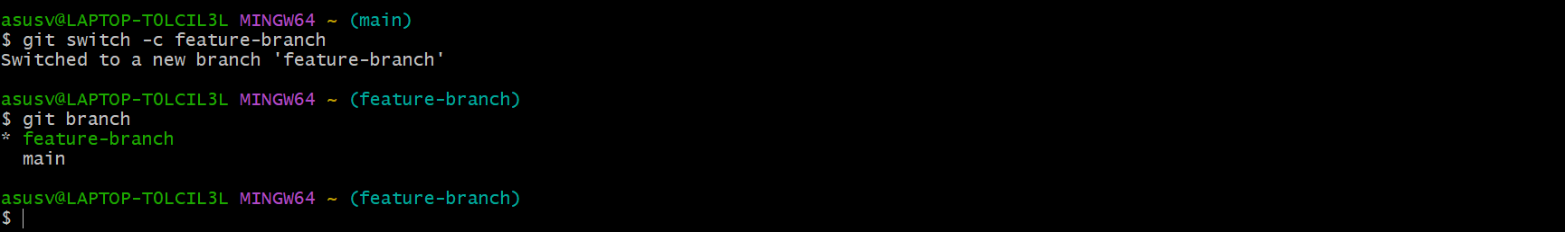
* **Q10:** Create a new file named feature.txt on your new branch and commit the changes. Then, switch back to the main branch.
* **Ans:** 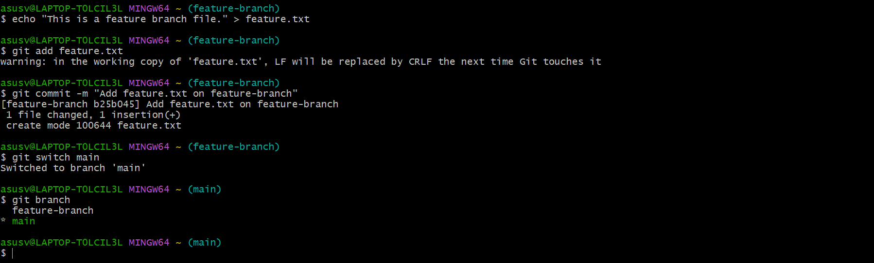
* **Q11:** Merge the feature-branch into the main branch. What command would you use to merge the changes, and what happens if there are no conflicts?
* **Ans:** 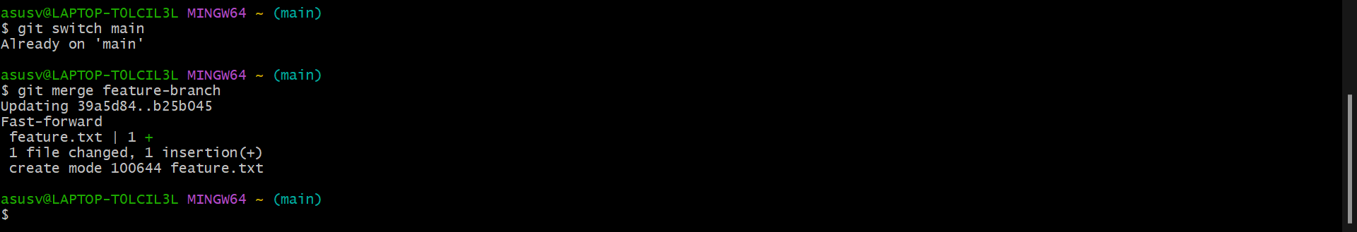

**Fast-Forward Merge**:

* If main has not diverged from feature-branch (i.e., no additional commits in main), Git performs a **fast-forward merge**.
* The branch pointer (main) simply moves forward to the latest commit on feature-branch.

**Three-Way Merge**:

* If main has diverged, Git creates a new merge commit to combine the changes from both branches.
* **Q12:** What is a merge conflict? Create a scenario where a merge conflict occurs and explain how you would resolve it.
* **Ans:** A merge conflict occurs in Git when two branches have changes to the same part of a file, and Git cannot automatically determine which changes to apply during a merge. It requires manual intervention to resolve the conflict.
* 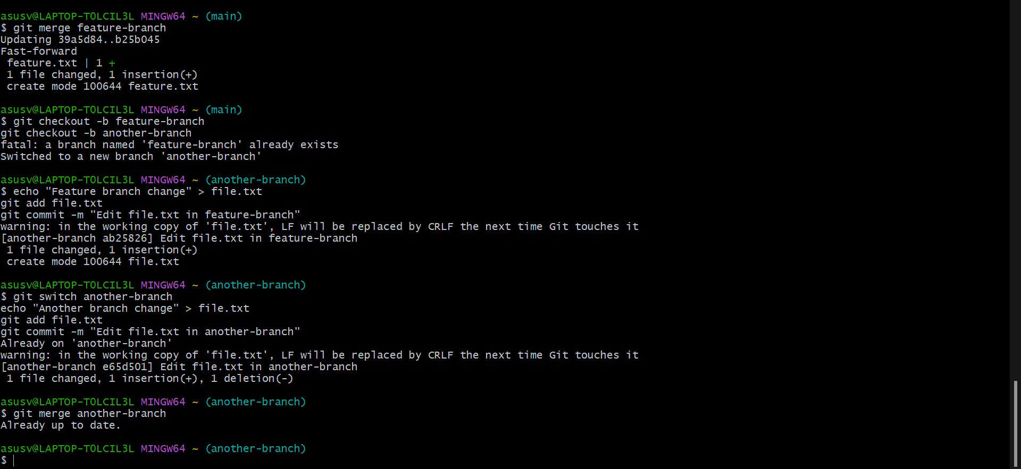

### **Resolving Conflicts:**

* Use Git tools like git diff to understand differences.
* GUI tools like **GitHub Desktop**, **GitKraken**, or IDE-integrated tools can simplify conflict resolution.
* Use commands like git merge --abort if you want to cancel the merge and start over.

### **4. Working with Remote Repositories:**

* **Q13:** What is a remote repository in Git? How is it different from a local repository?
* **Ans:** A **remote repository** in Git is a version of your project hosted on a server, usually accessible over a network or the internet. It serves as a central location where multiple developers can collaborate by pushing and pulling changes. Examples of platforms hosting remote repositories include GitHub, GitLab, Bitbucket, and Azure DevOps.
* A **local repository**, on the other hand, is a copy of the repository stored on your local machine. It allows you to work independently on the project without requiring a network connection.
* **Q14:** Clone a remote repository from GitHub to your local machine using the git clone command. Provide the URL of a public repository to clone.
* **Ans:** 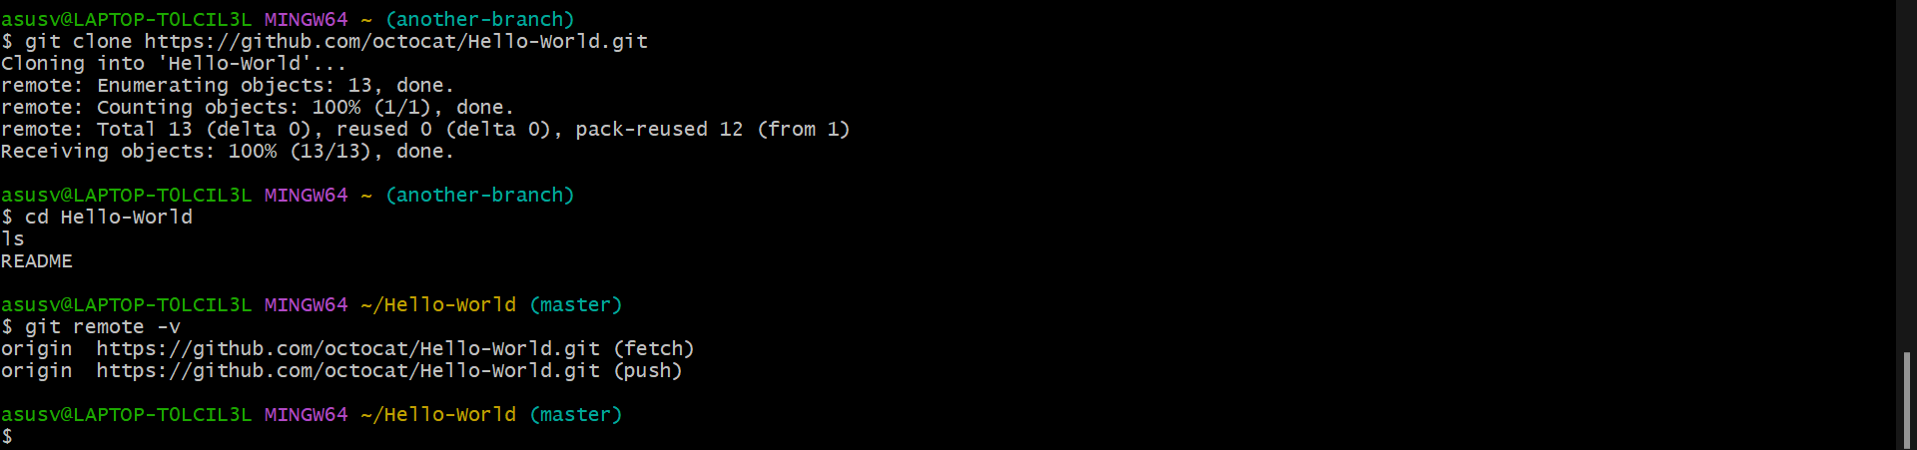
* **Q15:** After cloning the repository, make a small change (e.g., edit README.md), and commit the changes to your local repository.
* **Ans:** 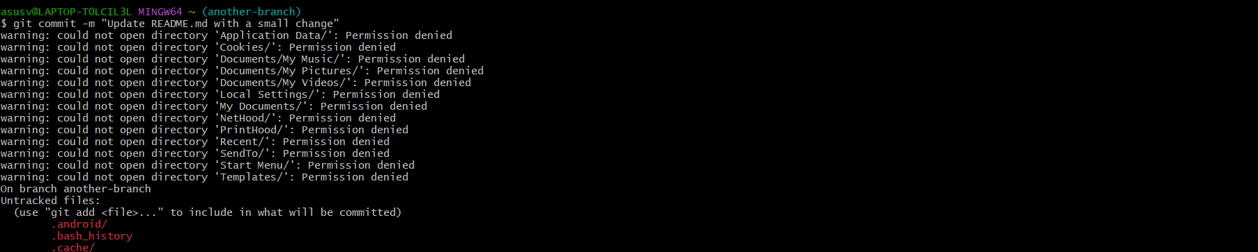
* **Q16:** Push your local commits to the remote repository. What Git command is used to push changes to a remote repository? Explain how you would use it.
* **Ans:** To push your local commits to a remote repository, you use the git push command.
* **Command to Push Changes:**
* bash
* Copy code
* git push origin <branch-name>
* **Explanation:**
* **git push**: This command uploads your local commits to a remote repository.
* **origin**: This is the default name for the remote repository you cloned from. It refers to the remote URL (in this case, the GitHub repository).
* **<branch-name>**: The name of the branch you want to push your changes to (e.g., main, feature-branch, etc.). If you're working on the main branch, it will look like this:
* bash
* Copy code
* git push origin main
* **Step-by-Step Process to Push Changes:**
* **Check the Branch You’re On**: Verify that you're on the correct branch before pushing:
* bash
* Copy code
* git branch
* The active branch will be marked with an asterisk (*). Ensure you’re on the branch you want to push to (e.g., main).
* **Push the Changes**: Push the local changes to the remote repository. For example, if you're on the main branch:
* bash
* Copy code
* git push origin main
* **Authentication**:
* If it's your first time pushing to the repository, Git might prompt you to authenticate with your GitHub username and password or personal access token.
* Alternatively, if you’ve set up SSH keys, Git will authenticate automatically.
* **Confirm the Push**: After pushing, you can verify that the changes were successfully uploaded by checking the repository on GitHub (or the remote hosting platform) or by running:
* bash
* Copy code
* git log
* to ensure your local commits match the remote history.
* **Push Behavior:**
* If the remote repository has no changes that conflict with your local commits, Git will upload the changes without issue.
* If the remote repository has new commits that your local repository does not have, you may need to **pull** those changes first and resolve any merge conflicts before pushing again.
* **Q17:** Fetch the latest changes from the remote repository using the git fetch command. What is the difference between git fetch and git pull?
* **Ans:** **git fetch Command:**
* The git fetch command is used to retrieve the latest changes from the remote repository without applying them to your local working directory. It updates your remote-tracking branches (like origin/main) with the latest commits from the remote repository, but it doesn't modify your local branches or working directory.
* **Command to Fetch Latest Changes:**
* bash
* Copy code
* git fetch origin
* This command retrieves the changes from the remote repository (origin), updating your local references of remote branches (e.g., origin/main).
* **Difference Between git fetch and git pull:**

| * **Aspect** | * **git fetch** | * **git pull** |
| --- | --- | --- |
| * **Purpose** | * Retrieves new commits from the remote without merging them into your current branch. | * Retrieves new commits and merges them into your current branch. |
| * **Effect on Local Repository** | * Updates remote-tracking branches (like origin/main) but does not affect your working directory or current branch. | * Fetches new commits and merges them with your local branch. Can affect your working directory if there are new changes. |
| * **Use Case** | * Useful when you want to see what others have done without merging their changes into your work immediately. | * Used when you want to immediately apply the remote changes to your local branch. |
| * **Merge Behavior** | * No merge happens. Fetching is purely to update references. | * Performs a merge (or rebase, depending on configuration) between the remote and local branches. |

### **5. Undoing Changes in Git:**

* **Q18:** After making several commits, you realize that a commit message needs to be changed. How can you edit the last commit message using Git?
* **Ans:** To change the last commit message in Git, you can use the git commit --amend command. This allows you to modify the message of the most recent commit without altering the content of the commit itself (unless you choose to make other changes as well).
* **Command to Edit the Last Commit Message:**
* bash
* Copy code
* git commit --amend
* **Steps to Edit the Last Commit Message:**
* **Run the git commit --amend Command**: This will open your default text editor with the current commit message.
* bash
* Copy code
* git commit --amend
* **Edit the Commit Message**:
* In the text editor, you'll see the current commit message.
* Modify the message as needed.
* Save the file and exit the editor to finalize the change.
* **Confirm the Change**: You can check that the commit message has been updated by running:
* bash
* Copy code
* git log --oneline
* This will show the latest commit with the updated message.
* **Important Notes:**
* **Only amend the last commit**: The git commit --amend command is meant for changing the most recent commit. It rewrites the commit history, so you should avoid using it for commits that have already been pushed to a shared remote repository unless you're working in a private branch.
* **What Happens If You've Already Pushed the Commit**:
* If the commit has been pushed to a remote repository, amending the commit will rewrite history. If you need to push the amended commit, you'll have to use the --force option:
* bash
* Copy code
* git push --force
* Be cautious when using --force, as it can overwrite changes on the remote repository, potentially causing issues for others working on the same branch.